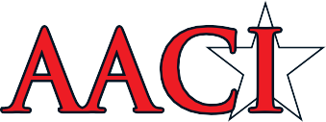
2020 NATIONAL HIGH SCHOOL SPORTS MEDICINE COMPETITION

ABOUT THE AMERICAN ACADEMIC COMPETITION INSTITUTE
In an effort to reduce the high costs of creating a national championship, The American Academic Competition Institute (AACI) has created a unique online event to challenge the minds of high school students. Our inaugural event was held in 2012.

Event Date:
Written Exam
- May 13, 14, 15, 18, 19, 20 Testing times - 7:00 am to 6:00 pm (PST)
- May 21, 2020 Testing times - 7:00 am to 12:30 pm (PST)
- School’s program director will submit request for time of exam on those dates

Our Mission Statement:
To celebrate the high school student’s knowledge of Sports Medicine/Athletic Training through a mentally challenging event.

Our Motto:
The Celebration of Knowledge

Students Compete as part of their school team, as well as on an individual basis (or both) Teams consist of 8 to 15 students from a single school. Each team’s top eight highest individual scores will be utilized to create a “Team Average” for the school. Both Teams and Individual Competitors are separated into one of three divisions based on the number of registered students attending their school:

Students at schools that did not place in top the top 10 of their respective division can compete if that student placed in the top 25 overall at their competition.

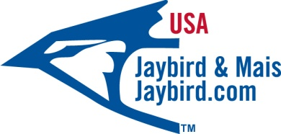

Cramer Sports Medicine (Large) Schools Division:
Includes schools with enrollments of more than 1,999

Jaybird & Mais Medium (Medium) Schools Division:
Includes schools with enrollments of 1000- 1,999

Henry Schcein Small Schools Division:
Includes schools with enrollments of more than 1- 999
- In the event of an enrollment discrepancy, the school in question must present a certified document with the school enrollment from the school administration/registrar at least 48 hours prior to the competition.

Team Eligibility:
Any school that has been ranked in the top 10 of any division (or overall) of a state or regional sports medicine competition/challenge in the past 12 months prior to the AACI Competition date are eligible to compete.

Individual Student Eligibility:
Students who compete as members of their schools team are also eligible to compete for individual awards. Individual students of schools that do not qualify for a team entry are eligible to compete for individual awards if the student competed in a state or regional competition/challenge in the 12 months prior to the AACI competition date, and placed in the top 25th percentile at the event.
Testing: The AACI National Competition consists of a 300 question online exam administered over a 2 hour time block. See study guide for further information.

Video Practical: A live video practical will be administered to the top 10 students in each division via Video Conference.

THE AWARDS
Team Awards: The top team average in each division will be named National Champion and will receive that Division’s National Championship Trophy. Second through Fifth place teams will also receive awards and recognition.

Awards (Individual): The students with the 25 highest scores in each division will be named AACI High School All-Americans in their respective divisions. The top ten students in each division will be administered a verbal practical via an Internet based video conference tool (Skype or FaceTime). The practical will be judged by a qualified representative of AACI. The point total of the practical plus the students written exam average will be combined to give the student their final standing in the division.

Scholarships: The students from each division with the 3 highest overall averages after combining written exam and video practical will receive a college scholarship awarded by their division sponsor.

Fees:
• Team entry fee (8 to 15 student participants) $600.00

• Student Entry fee (Not eligible for team awards) $75.00 per student

Registration Deadline: 3:00pm PST May 15th, 2020

For more information visit us at www.aacitest.com

American Academic Competition Institute, LLC
25876 The Old Road, Suite# 231. Stevenson Ranch, CA. 91381
818-642-7238
info@aacitest.com

